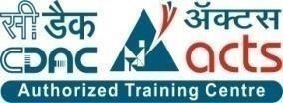

INSTITUTE FOR ADVANCED COMPUTING AND

SOFTWARE DEVELOPMENT AKURDI, PUNE

Documentation On

**“D-DARSHAN AND TOUR”**

PG-DAC SEPT 2022

**Submitted By:**

**Group No: 91**

|  |  |
| --- | --- |
| **Roll No.** | **Name:** |
| **229184** | **Prashant Sawant** |
| **229194** | **Roshan Kanwade** |
| **Mr. Rohit Puranik** | **Mrs. Monica Jadhav** |
| **Centre Coordinator** | **Project Guide** |

**ABSTRACT**

Our web application offers hassle-free and convenient hotel booking services for

those who are planning to visit temples. Our platform provides a user-friendly

interface, making it easy for users to search for hotels that are located near temples.

With our platform, users can select from a wide range of hotels that are suited to

their preferences and budget. Our website features a comprehensive list of hotels

that are located within the vicinity of the temple, complete with their amenities,

rates, and availability. Users can also compare prices and read reviews from other

travelers before making their final decision.

Our platform ensures a seamless booking process. Users can make reservations

and pay securely through our website, eliminating the need for additional

communication with the hotel. In case of any concerns or questions, our customer

service team is available 24/7 to assist our users.

Overall, our web application provides a reliable and convenient solution for those

who want to book a hotel near temples. Our goal is to make it easier for travelers

to plan their trip, experience the beauty and culture of the temples, and create

unforgettable memories.

## ACKNOWLEDGEMENT

I take this occasion to thank God, almighty for blessing us with his

grace and taking our endeavor to a successful culmination. I extend my sincere and heartfelt thanks to our esteemed guide, **Mrs. Monica Jadhav** for providing me with the right guidance and advice at the crucial juncture sand for showing me the right way. I extend my sincere thanks to our respected **Centre Co-Ordinator Mr. Rohit Puranik**, for allowing us to use the facilities available. I would like to thank the other faculty members also, at this occasion. Last but not the least, I would like to thank my friends and family for the support and encouragement they have given me during the course of our work.

**Prashant Sawant (229184)**

**Roshan Kanwade (229194)**

**Table of Content**

ABSTRACT…………………………………………………………………………………………..…2

ACKNOWLEDGEMENT 3

Features:- 8

1.1 PROJECT OBJECTIVE :- 9

1.2 PROJECT OVERVIEW:- 10

1.3 PROJECT SCOPE:- 11

1.4 STUDY OF THE SYSTEM 12

1.4.1 MODULES: 12

SYSTEM ANALYSIS 17

2.1 EXISTING SYSTEM 17

2.2 PROPOSED SYSTEM 18

2.3 SYSTEM REQUIREMENT SPECIFICATION 19

Title: 19

2.3.1 GENERAL DESCRIPTION 19

2.3.2 SYSTEM OBJECTIVES :- 19

2.3.3 SYSTEM REQUIREMENTS 20

Description of features:- 22

3.SYSTEM DESIGN 23

3.1 INPUT AND OUTPUT DESIGN 24

3.1.1 INPUT DESIGN: 24

3.1.2 OUTPUT DESIGN: 24

DATABASE DESIGN 25

3.2 DATABASE 25

3.3 SYSTEM TOOLS 25

3.3.1 FRONT END: 25

3.3.2 BACKEND: 25

DATA FLOW DAIGRAMS: 27

0 Level DFD 27

1 Level DFD 28

E-R Diagram:- 30

TABLE STRUCTURE: 35

PROJECT DIAGRAMS : 40

CONCLUSION 52

REFERENCES 53

**LIST OF FIGURES:-**

**FIGURE 1: ACTIVITY DIAGRAM ----------------------------------------------------------------------- 16**

**FIGURE 2: 0 LEVEL DFD ---------------------------------------------------------------------------------- 27**

**FIGURE 3: 1 LEVEL DFD --------------------- ------------------------------------------------------------ 29**

**FIGURE 4: E-R DIAGRAM 1.a ---------------------------------------------------------------------------- 30**

**FIGURE 5: E-R DIAGRAM 1.b------------------------------------ ---------------------------------------- 31**

**FIGURE 6: CLASS DIAGRAM ---------------------------------------------------------------------------- 32**

**FIGURE 7: SEQUENCE DAIGRAM --------------------------------------------------------------------- 33**

**FIGURE 8: ACTIVITY DAIGRAM ----------------------------------------------------------------------- 34**

**FIGURE 9: TABLE STRUCTURE ------------------------------------------------------------------------ 35**

**FIGURE 10: PROJECT DIAGRAMS ---------------------------------------------------------------------40**

**INTRODUCTION**

Welcome to our web application for hotel booking near temples. Our application is

designed to provide a convenient and hassle-free experience for those seeking

accommodation near their preferred temple. With our user-friendly interface,

users can easily search for hotels located in close proximity to their desired temple,

compare prices, and make reservations quickly and securely.

Our application offers a wide range of accommodation options, from budget-friendly

to luxurious amenities, and customer ratings. Our platform also features detailed

hotel descriptions and photos, allowing users to make an informed decision before making a reservation.

Our team is dedicated to ensuring that our users have a smooth and enjoyable experience

while using our platform. We provide excellent customer support, and our team is always

ready to assist users with any questions or concerns they may have. Additionally,

our application is optimized for mobile devices, allowing users to book hotels on-the-go.

With our web application, users can book hotels near their preferred temple with ease and

convenience, saving time and effort. We believe that our application will serve as a valuable

tool for those seeking comfortable and affordable accommodation near their desired temple.

Thank you for choosing our platform, and we look forward to helping you find the perfect hotel

for your next temple visit.

## Features:-

1.Advanced search functionality - users can search for hotels near their desired

temple by location, price, and amenities.

2.Multiple payment options - our platform supports multiple payment methods,

including credit cards, debit cards.

3.Detailed hotel descriptions and photos - users can view detailed descriptions

and photos of each hotel to make an informed decision.

4.User accounts - users can create accounts to save their preferences, view past

bookings, and receive personalized recommendations.

5.Mobile-friendly - our platform is optimized for mobile devices, allowing users

to book hotels on-the-go.

6.Real-time availability - users can see real-time availability of hotels and

make reservations quickly and easily.

7.Secure booking process - our platform uses advanced encryption and security

protocols to ensure that users' personal information is kept safe and secure.

8.Group bookings - users can book multiple rooms for a group of people at once

and receive discounts for bulk bookings.

9.Hotel amenities - users can view a list of amenities offered by each hotel,

such as Wi-Fi, parking, gym, and swimming pool.

10.Cancelation policies - users can view the cancelation policies of each hotel

before making a reservation to avoid any confusion or unexpected charges.

## 1.1 PROJECT OBJECTIVE :-

The objective of our hotel booking near temple web application is to provide a

user-friendly platform for individuals and families seeking accommodation near

their preferred temple. Our goal is to make the process of booking hotels near

temples convenient, easy, and hassle-free. We aim to provide a wide range of

accommodation options and features to cater to the diverse needs of our users,

including advanced search functionality, multiple payment options, rea l-time

availability, and secure booking processes.

Our ultimate objective is to create a valuable tool that helps users save time

and effort while finding the perfect hotel for their next temple visit.

## 1.2 PROJECT OVERVIEW:-

Our hotel booking near temple web application is designed to provide a seamless and

efficient experience for users seeking accommodation near their preferred temple.

The application is built using a variety of technologies, including MySQL

for data storage, Springboot, Spring Jpa, Hibernate for the backend, and HTML5,

CSS3, Bootstrap and ReactJs for the frontend.

The application has a user-friendly interface that allows users to search for hotels

near their desired temple using various filters, like location.

To enhance the user experience, we have included a range of features, such as

real-time availability, multiple payment options, and secure booking processes.

Users can also create accounts to save their preferences, view past bookings.

The application has a robust backend that manages user data and interactions.

It uses MySQL as a data store to manage user information, hotel details,

and bookings. The application has a relation between the user and the

booking system, allowing users to make and manage their bookings easily.

Overall, our hotel booking near temple web application is a comprehensive

tool that provides users with a convenient and efficient way to find and book

accommodation near their preferred temple. The application is designed

to be user-friendly, secure, and reliable, and we are committed to continuously

improving and enhancing it to meet the needs of our users.

## 1.3 PROJECT SCOPE:-

## 

The scope of our hotel booking near temple web application is to provide a

user-friendly platform for individuals and families seeking accommodation

near their preferred temple. The application will allow users to search for

hotels based on filter like places and make secure bookings with multiple

payment options. The application will have a relation between the user and

the booking system, allowing users to manage their bookings easily.

## 1.4 STUDY OF THE SYSTEM

### 1.4.1 MODULES:

The system after careful analysis has been identified to be presented with the following modules and roles. The modules involved are:

* Administrator

* Service Provider

* Users

1.4.1.1 Administrator:

The administrator is the super user of this application. Only admin have access into this admin page. Admin may be the owner of the shop. The administrator has all the information about the users and about all products. This module is divided into different sub modules.

1.Manage room availability: Admins should be able to view and update the availability of rooms on the website. This includes adding new rooms, updating room rates, and setting availability for specific dates.

2.Manage user accounts: Admins should be able to view and manage user accounts, including adding new users, editing user details, and deleting user accounts if necessary.

3.Manage bookings: Admins should be able to view and manage all bookings made through the website, including editing booking details, canceling bookings, and

refunding payments if necessary.

4.Manage payment processing: Admins should be able to view and manage all

payment transactions made through the website, including processing refunds, verifying payment information, and handling payment disputes.

5.Manage reviews and ratings: Admins should be able to view and manage user reviews and ratings of the hotel and its facilities, including approving reviews, responding to feedback, and removing inappropriate content.

6.Manage promotional offers: Admins should be able to create and manage promotional offers for users, including setting discounts and coupon codes, scheduling promotional periods, and tracking the effectiveness of different offers.

7.Generate reports: Admins should be able to generate various reports on website activity, including booking trends, revenue analysis, and user demographics.

8.Manage website content: Admins should be able to update and manage website content, including adding new photos, editing room descriptions, and updating information about hotel facilities and services.

9.Manage security settings: Admins should be able to manage security settings for the website, including setting password requirements, enabling two-factor authentication, and monitoring login attempts for suspicious activity.

10.Manage customer support: Admins should be able to provide customer support to users through various channels, including email, phone, and live chat. This includes handling customer inquiries, resolving issues, and providing technical support when necessary.

***Activity:***

**1.User registration: Users can create an account on the website by providing**

**their personal information, such as name, email, and password.**

**2.User login: Users can log in to their account on the website using**

**their email and password.**

**3.Room search: Users can search for available rooms based on their**

**preferred dates, location, and other criteria.**

**4.Room selection: Users can select a room from the list of available rooms that**

**matches their preferences and budget.**

**5.Booking confirmation: Users can confirm their booking by providing their**

**payment information, including credit card details or other payment methods.**

**6.Payment processing: The website processes the payment for the booking using**

**a secure payment gateway.**

**7.Booking confirmation email: The website sends an email to the user with the**

**booking details and confirmation.**

**8.Room availability update: The website updates the availability of the room**

**in real-time to prevent double bookings.**

**9.Cancel booking: Users can cancel their booking if necessary and receive**

**a refund if applicable.**

**10.Admin login: Admins can log in to their admin account on the website**

**using their mobno and password.**

**11.Manage rooms: Admins can manage the availability of rooms, update room rates,**

**and add new rooms.**

**12.Manage bookings: Admins can view and manage all bookings made through**

**the website, including editing booking details, canceling bookings, and refunding payments.**

**13.Manage payments: Admins can manage all payment transactions made**

**through the website, including processing refunds, verifying payment information,**

**and handling payment disputes.**

**14.Manage website content: Admins can update and manage website content,**

**including adding new photos, editing room descriptions, and updating information**

**about hotel facilities and services.**

**15.Manage security settings: Admins can manage security settings**

**for the website, including setting password requirements,**

**enabling two-factor authentication, and monitoring login attempts**

**for suspicious activity.**

***Figure 1 Activity Diagram*** 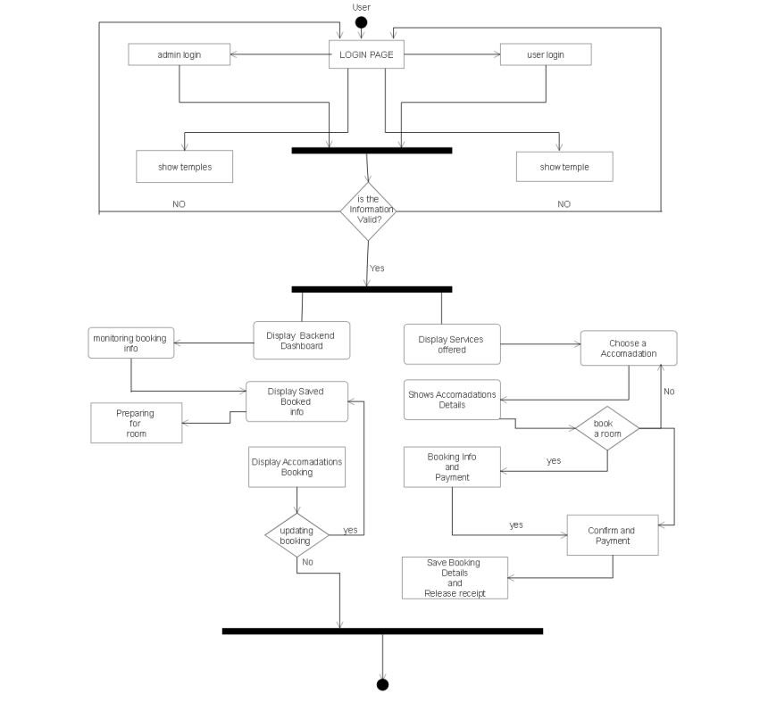

## SYSTEM ANALYSIS

A hotel booking web app would involve a system analysis that includes understanding

the various functions and features required, such as user registration, room selection,

payment processing, and booking confirmation.

It would also involve analyzing user behavior, database design, security, and scalability requirements.

The system would need to be user-friendly, efficient, reliable, and customizable to meet the

needs of both the hotel and the customers.

## 2.1 EXISTING SYSTEM

The current system for booking is to visit the website which are with hotel booking system

And book there hotel and match the temple site which is near to them there is lack

Of mis-coridinate between hotel and temple and its become difficult to visitors to stay near

temple .

* It is less user-friendly.
* User must go to the two different website like hotel website and religious website.
* It is difficult to identify the right hotel to pick up.
* Description of the hotel is limited.
* It is a time-consuming process .
* Not in reach of distant users.

## 2.2 PROPOSED SYSTEM

In the proposed system there are lot of functionalities where added and there are

Listed as belows:

1.User Registration and Login: Users can create an account or login via mob No and password.

2.Search Functionality: Users can search for hotels based on criteria such as location, temple, etc.

3.Room Booking: Users can select and book hotel rooms based on their preferences, including room type, occupancy, and price.

4.Payment Gateway Integration: Users can pay for their bookings using a secure payment gateway that supports multiple payment methods.

5.Booking Confirmation: Users receive a confirmation email or message with their booking details, including reservation dates, room type, and price.

6.Reservation Management: Users can modify or cancel their bookings, view their booking history, and provide feedback or ratings.

7.Hotel Listings: Hotels can create and manage their listings, including room availability, pricing, and amenities.

8.Security: The app has robust security measures in place, including SSL encryption, two-factor authentication, and regular vulnerability scans, to ensure the safety and privacy of user data.

## 2.3 SYSTEM REQUIREMENT SPECIFICATION

**Title:**

**D-Darshan and Tour.**

### 2.3.1 GENERAL DESCRIPTION

**Project Description:**

The hotel booking web app is an online platform for users to search, compare, and book rooms in various religoius locations. The application provides a user-friendly interface that allows users to browse through different hotels, view room details, amenities, and prices, and make reservations.

**Problem Statement:**

As online shopping became a trend nowadays the regular shops are losing their customers to online brands. Customers have effortless shopping experience and saving time through shopping online. For competing with those online brands, if shops are providing an online portal where their customers can shop through internet and get the products at their doors it will increase the number of customers.

### 2.3.2 SYSTEM OBJECTIVES :-

The web app that allows users to search and book hotels that are located near a specific temple.

Users should be able to enter the name or location of the temple and view a list of hotels in the vicinity.

The app should display key information about each hotel, such as price, rating, and availability,

and allow users to easily make a reservation. The app should also include a map that shows the

location of the temple and hotels in the area.

### 2.3.3 SYSTEM REQUIREMENTS

**2.3.3.1 NON-FUNCTIONAL REQUIREMENTS**

1.Security: The system should be secure and protect user data from unauthorized access

and manipulation.

2.Performance: The system should be fast and responsive, with quick page loading times

and minimal downtime.

3.Scalability: The system should be able to handle a large number of users and hotel

listings without performance degradation.

4.Usability: The system should be easy to use, with a clean and intuitive user interface that

provides clear instructions and feedback.

5.Availability: The system should be available 24/7, with minimal downtime for maintenance

and updates.

6.Compatibility: The system should be compatible with multiple devices and platforms,

including desktops, laptops, tablets, and smartphones.

7.Localization: The system should support multiple languages and currencies to cater to a

global audience.

* + - 1. **FUNCTIONAL REQUIREMENTS :-**

1.User Registration: The system should provide a user registration form that allows users to create a new account with their name, email address, and password. Users should also have the option to sign in with their social media accounts.

2.Search and Filters: Users should be able to search for hotels by location, date range, room type, and price range. The system should provide a list of hotels that match the search criteria, along with filters to refine the results.

3.Hotel Details: Users should be able to view detailed information about each hotel, including photos, room descriptions, amenities, and user reviews.

4.Booking: Users should be able to make reservations by selecting the room type, dates, and payment information. The system should provide a confirmation message and email notification to the user once the booking is complete.

5.Payment: The system should support multiple payment methods, including credit card, and bank transfer. Payment should be processed securely and efficiently.

6.User Profile: The system should allow users to view and manage their profile information, including booking history, saved hotels, and payment details.

7.Hotel Owner Dashboard: The system should provide a dashboard for hotel owners to manage their hotel information, room availability, and pricing.

**MODERATOR**

## Description of features:-

A moderator is a person responsible for managing and regulating discussions or interactions

within a community, forum, or social media platform. They ensure that participants follow

the rules and guidelines and maintain a respectful and constructive environment.

Moderators may also facilitate communication between users, respond to questions or

concerns, and handle disputes. Their role is crucial in promoting healthy discussions and

preventing spam, harassment, and other types of abuse.

As a moderator for a hotel booking web app, moderator primary responsibility is to ensure that the platform operates smoothly and efficiently. You will be responsible for monitoring user activity, enforcing community guidelines, and resolving disputes between users.

Moderator duties will include reviewing user-generated content, such as reviews and comments, to ensure they are appropriate and do not violate the platform's policies. You will need to respond to user inquiries, complaints, and reports promptly and professionally.

Moderator should also be prepared to handle sensitive information, such as personal data and payment information, with discretion and care.

As a moderator, he/she will work closely with the development team to identify and report bugs, suggest improvements, and implement changes to the platform. You should be familiar with the platform's features and be able to troubleshoot issues that may arise.

Finally, he/she should stay up-to-date on industry trends, user needs, and best practices for online communities to ensure the platform is meeting user expectations and evolving to stay competitive.

## 3.SYSTEM DESIGN

System design is the process of defining the architecture, components, modules, interfaces, and data for a system to satisfy specified requirements. It involves identifying the needs of users, analyzing system functionality, and designing a solution that meets those needs. It encompasses both software and hardware aspects of a system, including performance, scalability, security, maintainability, and usability. Effective system design involves breaking down complex problems into smaller, more manageable components, and optimizing each component for its intended purpose. It requires a deep understanding of system requirements, programming languages, software development methodologies, and industry best practices. Good system design can result in systems that are efficient, reliable, and easy to use, while poor system design can lead to slow performance, frequent errors, and high maintenance costs.. System design has two phases of development.

* Logical Design
* Physical Design

During logical design phase the analyst describes inputs (sources), outputs(destinations), databases (data sores) and procedures (data flows) all in a format that meets the user requirements. The analyst also specifies the needs of the user at a level that virtually determines the information flow in and out of the system and the data resources. Here the logical design is done through data flow diagrams and database design. The physical design is followed by physical design or coding. Physical design produces the working system by defining the design specifications, which specify exactly what the candidate system must do. The programmers write the necessary programs that accept input from the user, perform necessary processing on accepted data and produce the required report on a hard copy or display it on the screen.

## 3.1 INPUT AND OUTPUT DESIGN

### 3.1.1 INPUT DESIGN:

Input design is the link that ties the information system into the world of its users. The input design involves determining the inputs, validating the data, minimizing the data entry and provides a multi-user facility. Inaccurate inputs are the most common cause of errors in data processing. Errors entered by the data entry operators can be controlled by input design. The user-originated inputs are converted to a computer-based format in the input design. Input data are collected and organized into groups of similar data. Once identified, the appropriate input media are selected for processing. All the input data are validated and if any data violates any conditions, the user is warned by a message. If the data satisfies all the conditions, it is transferred to the appropriate tables in the database. In this project the student details are to be entered at the time of registration. A page is designed for this purpose which is user friendly and easy to use. The design is done such that users get appropriate messages when exceptions occur.

### 3.1.2 OUTPUT DESIGN:

Computer output is the most important and direct source of information to the user. Output design

is a very important phase since the output needs to be in an efficient manner. Efficient and intelligible output design improves the system relationship with the user and helps in decision making. Allowing the user to view the sample screen is important because the user is the ultimate judge of the quality of output. The output module of this system is the selected notifications.

## DATABASE DESIGN

## 3.2 DATABASE

Databases are the storehouses of data used in the software systems. The data is stored in tables inside the database. Several tables are created for the manipulation of the data for the system. Two essential settings for a database are

▪ Primary key - the field that is unique for all the record occurrences ▪ Foreign key - the field used to set relation between tables

Normalization is a technique to avoid redundancy in the tables.

## 3.3 SYSTEM TOOLS

The various system tools that have been used in developing both the front end and the back end of the project are being discussed in this chapter.

### 3.3.1 FRONT END:

React is a library which is developed by Facebook are utilized to implement the frontend. React (also known as React.js or ReactJS) is a [free and open-source](https://en.wikipedia.org/wiki/Free_and_open-source_software) [front-end](https://en.wikipedia.org/wiki/Front_end_and_back_end) [JavaScript library](https://en.wikipedia.org/wiki/JavaScript_library) for building [user interfaces o](https://en.wikipedia.org/wiki/User_interfaces)r UI components. It is maintained by [Facebook a](https://en.wikipedia.org/wiki/Facebook%2C_Inc)nd a community of individual developers and companies. React can be used as a base in the development of [single page o](https://en.wikipedia.org/wiki/Single-page_application)r mobile applications. However, React is only concerned with state management and rendering that state to the [DOM,](https://en.wikipedia.org/wiki/Document_Object_Model) so creating React applications usually requires the use of additional libraries for routing, as well as certain client-side functionality.

### 3.3.2 BACKEND:

The back end is implemented using MySQL which is used to design databases.

**MySQL:**

MySQL is the world's second most widely used open-source relational database management system (RDBMS). The SQL phrase stands for Structured Query Language. An application software called Navicert was used to design the tables in MySQL.

**Spring-Boot:**

This is used to connect MYSQL and fetch data from database and store the data in database. The Spring Framework is a[n application framework a](https://en.wikipedia.org/wiki/Application_framework)nd [inversion of control](https://en.wikipedia.org/wiki/Inversion_of_control) [container f](https://en.wikipedia.org/wiki/Servlet_container)or the [Java platform. T](https://en.wikipedia.org/wiki/Java_platform)he framework's core features can be used by any Java application, but there are extensions for building web applications on top of the [Java EE (](https://en.wikipedia.org/wiki/Java_EE)Enterprise Edition) platform. Although the framework does not impose any specific [programming model,](https://en.wikipedia.org/wiki/Programming_model) it has become popular in the Java community as an addition to the [Enterprise JavaBeans (](https://en.wikipedia.org/wiki/Enterprise_JavaBeans)EJB) model. The Spring Framework is Open-source Framework.

# DATA FLOW DAIGRAMS:

# 0 Level DFD

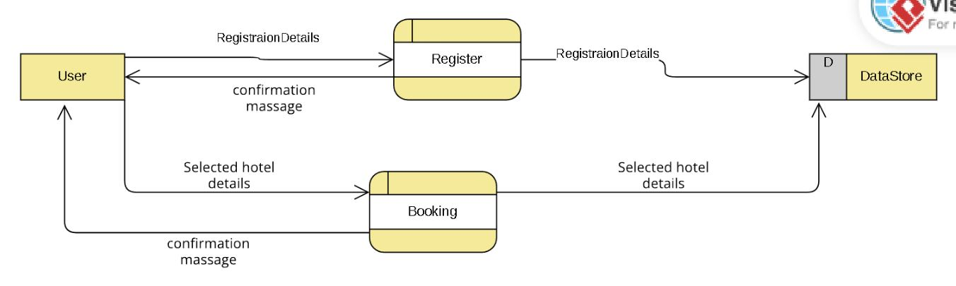

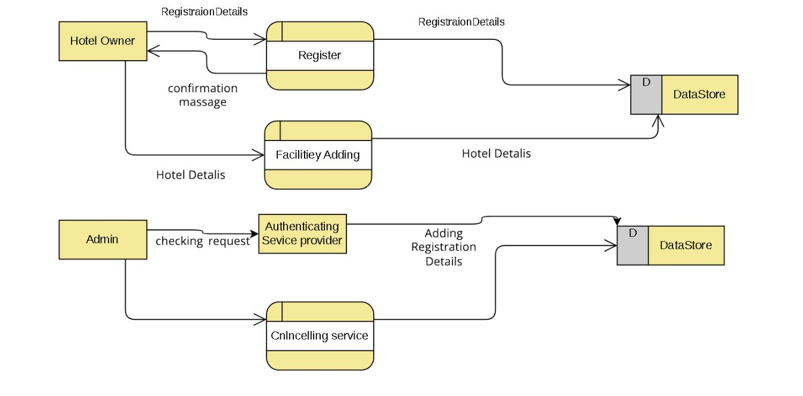

***Figure 2. 0 Level DFD***

# 1 Level DFD

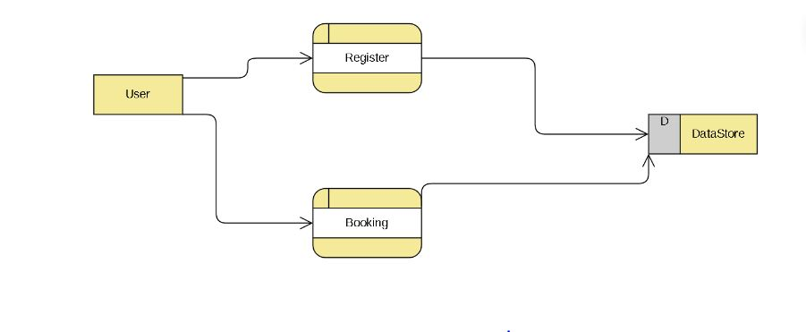

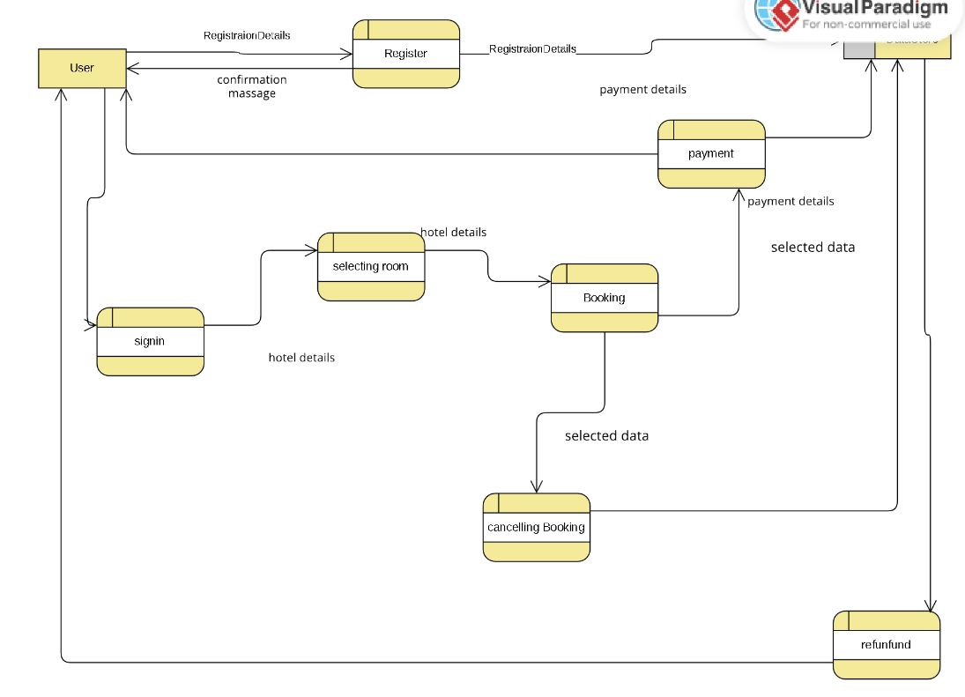

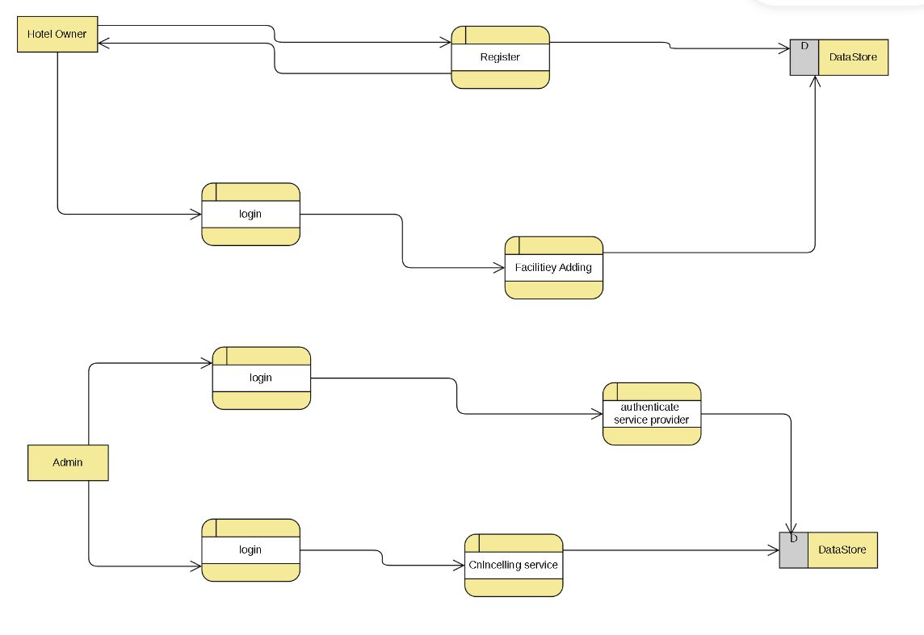

***Figure 3. 1 Level DFD***

# E-R Diagram:-

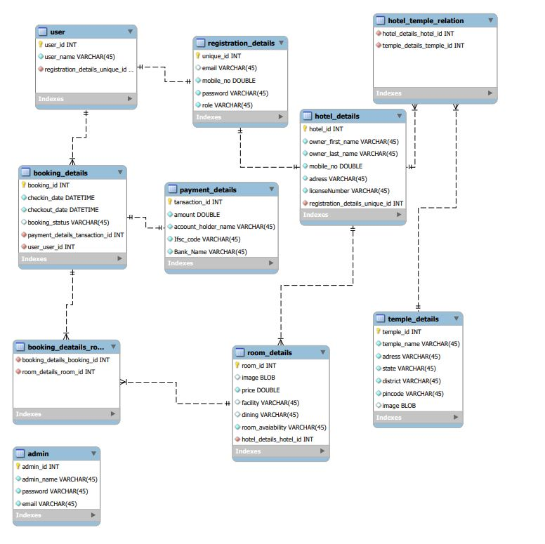

***Figure 4.a E-R Diagram***

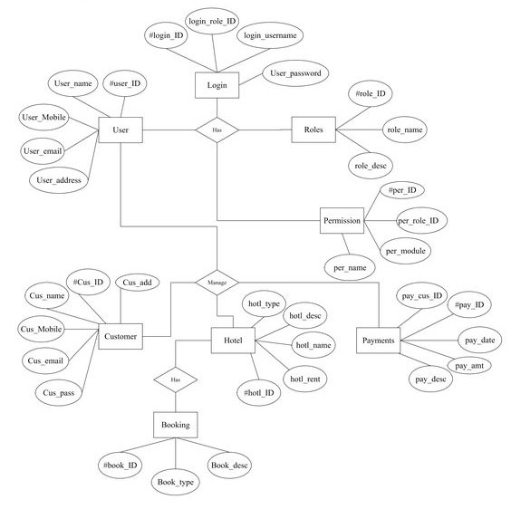

***Fig 4.b E-R Daigram.***

**Class Diagram:-**

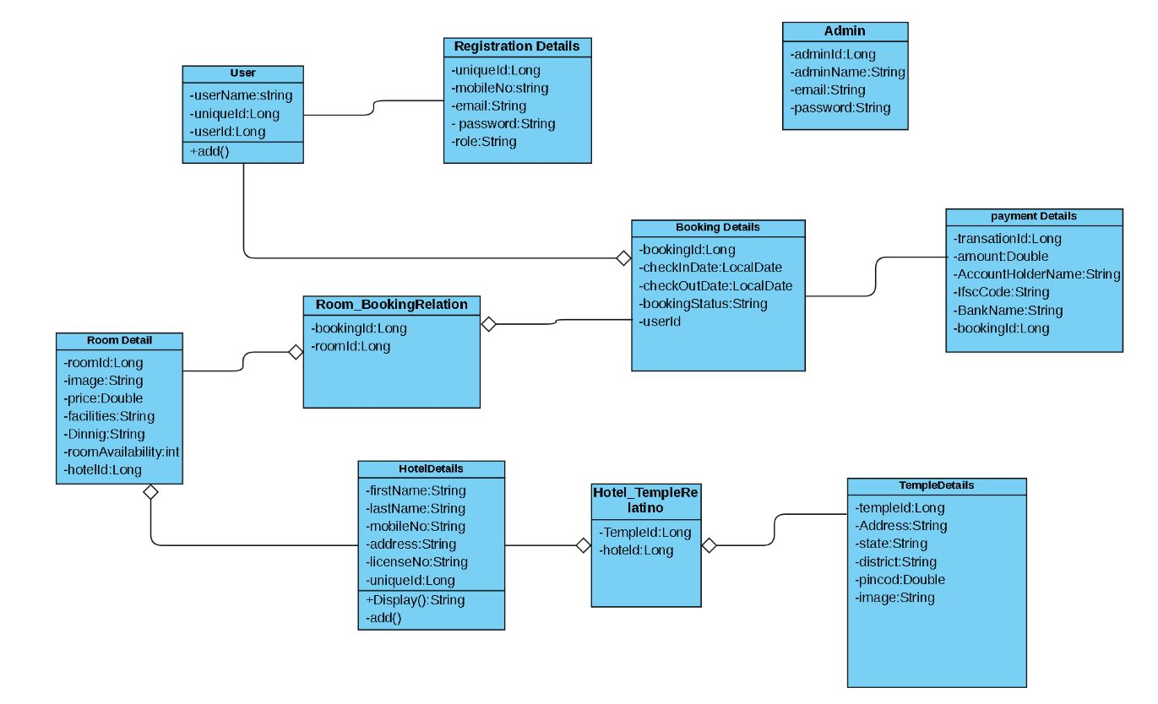

***Figure 8 Class Diagram***

**Sequence Daigram:-**

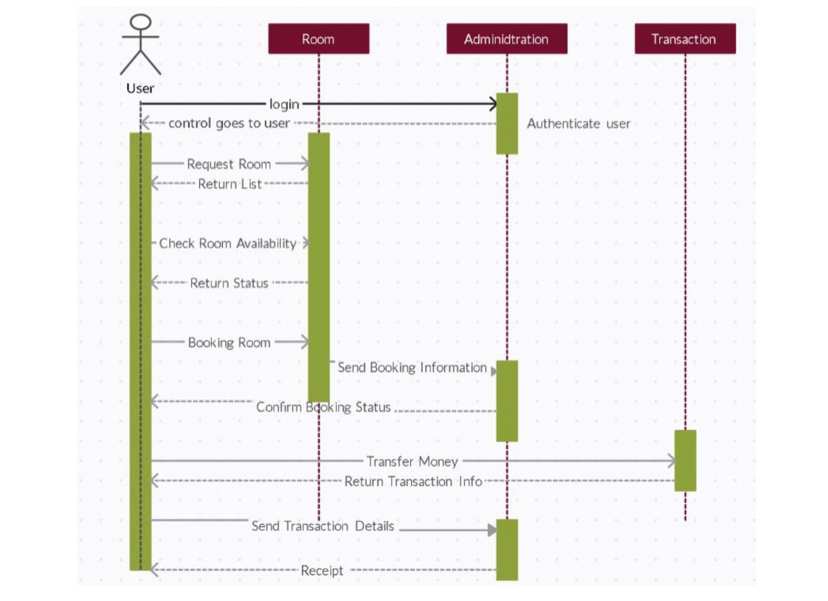

**Activity Daigram:-**



# TABLE STRUCTURE:

**Tables:**

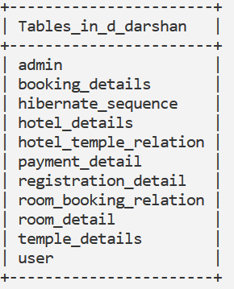

1. **Admin:**

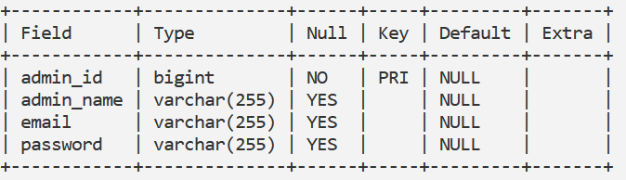

1. **BookingDetails:**

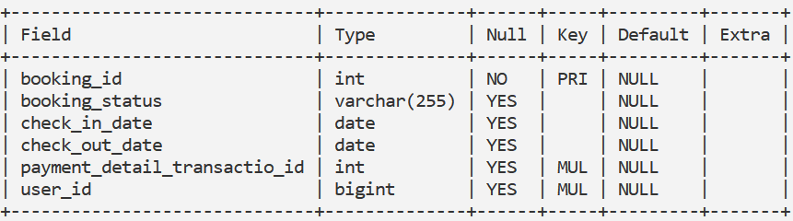

**3)HotelDetails:**

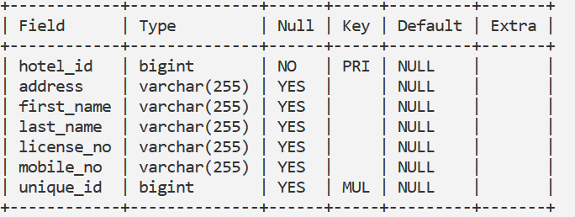

1. **Hotel_Temple_Relation:**

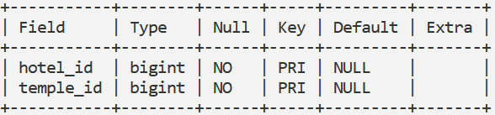

1. **Payment_Details:**

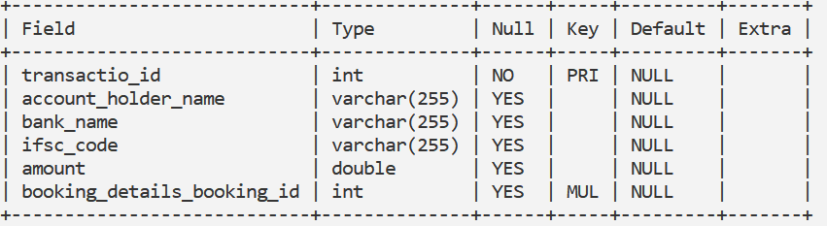

1. **Registration_Details:**

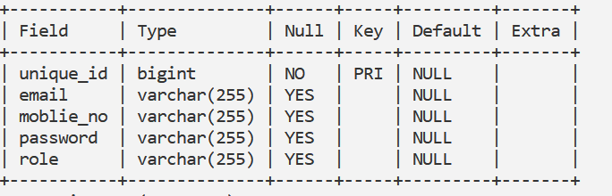

1. **Room_Booking_Relation:**

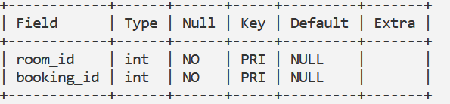

1. **Room_Details:**

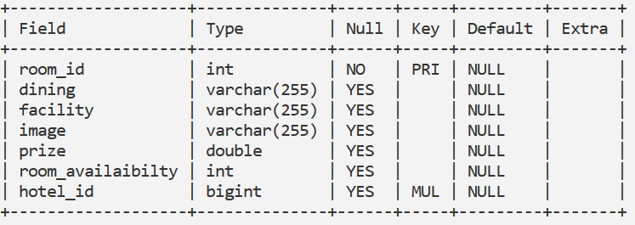

1. **Temple_Details:**

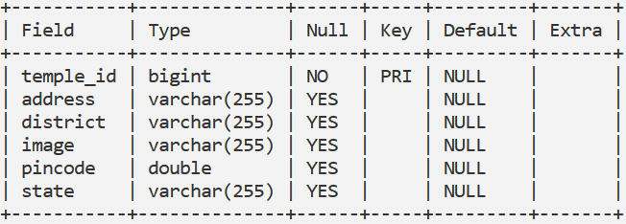

1. **User:**

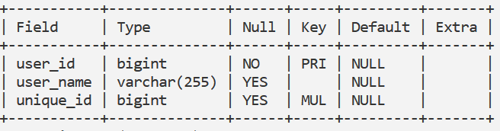

# PROJECT DIAGRAMS :

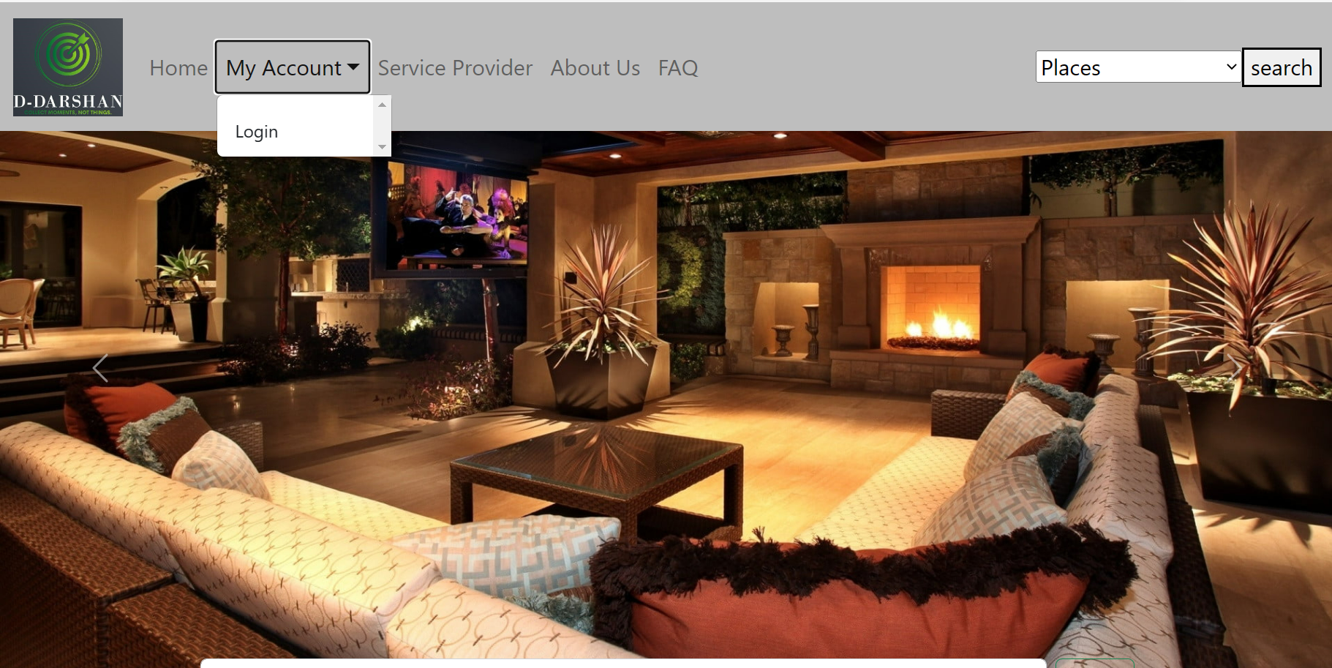

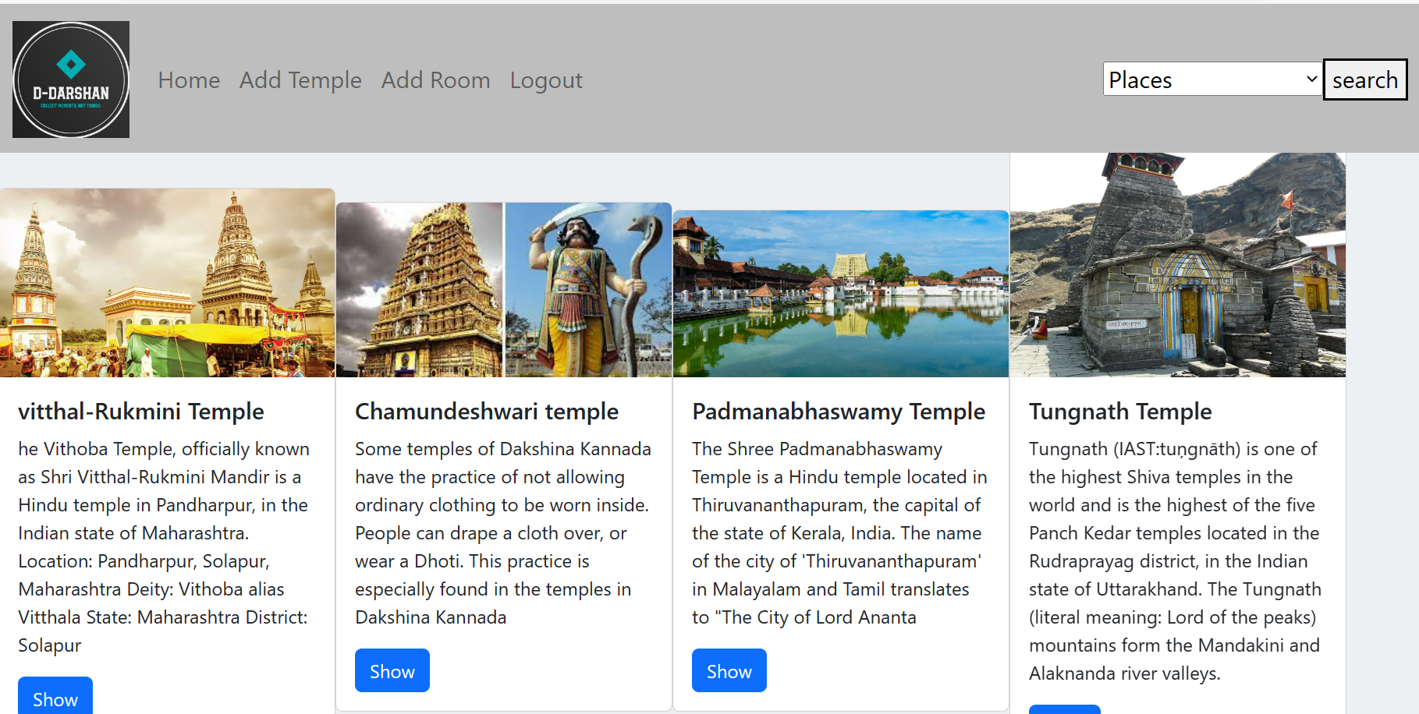

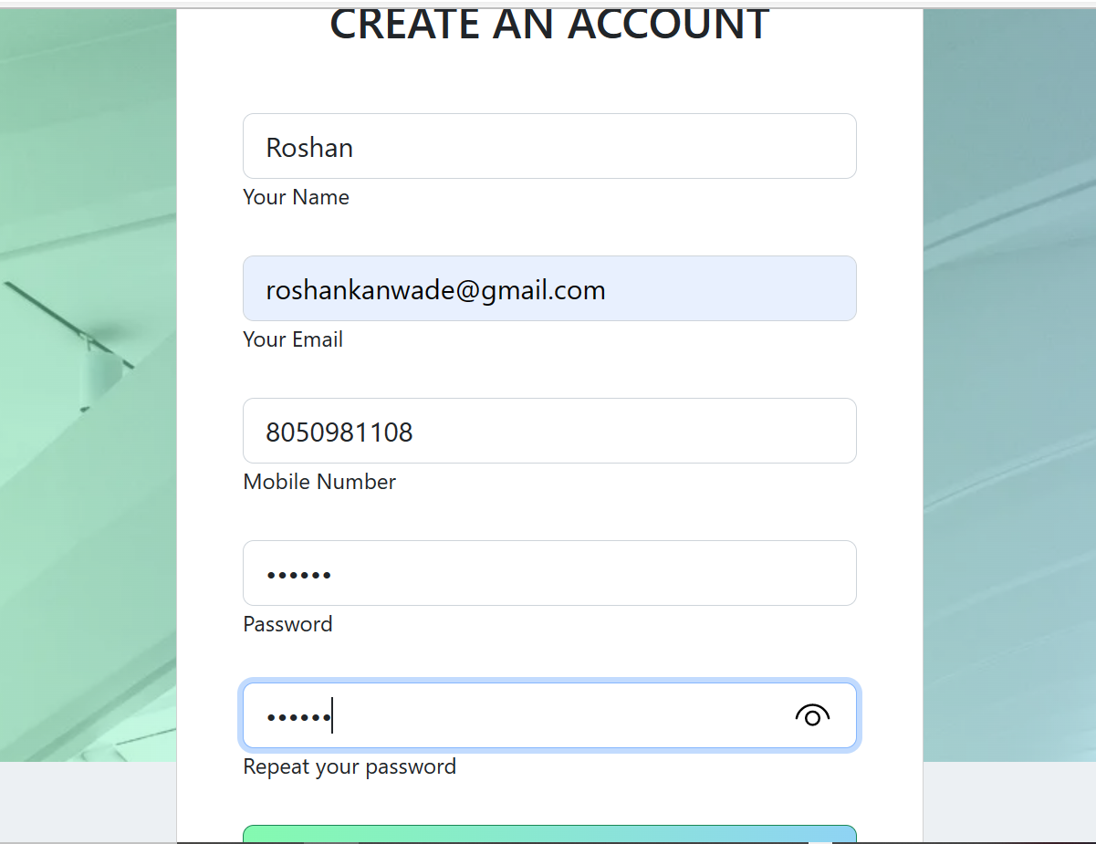

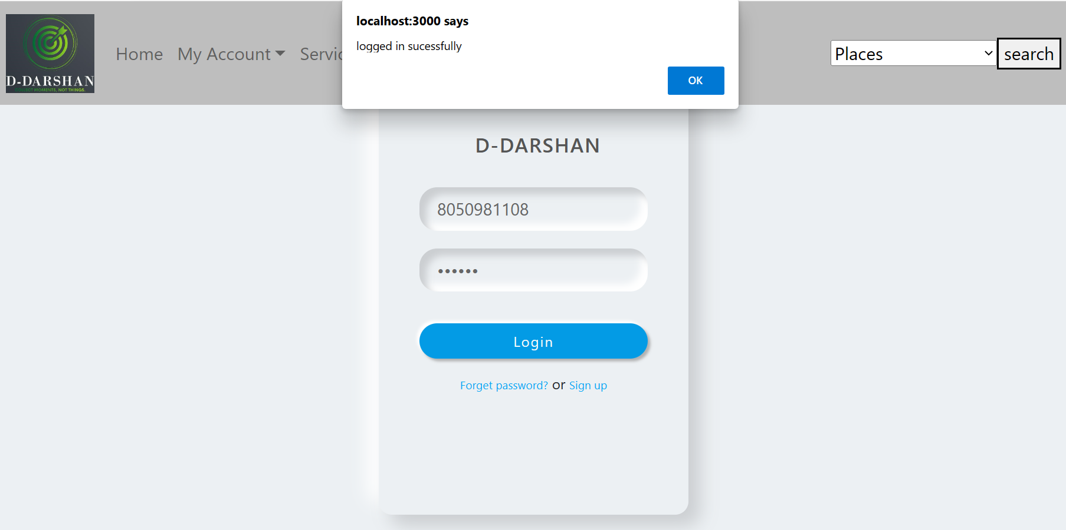

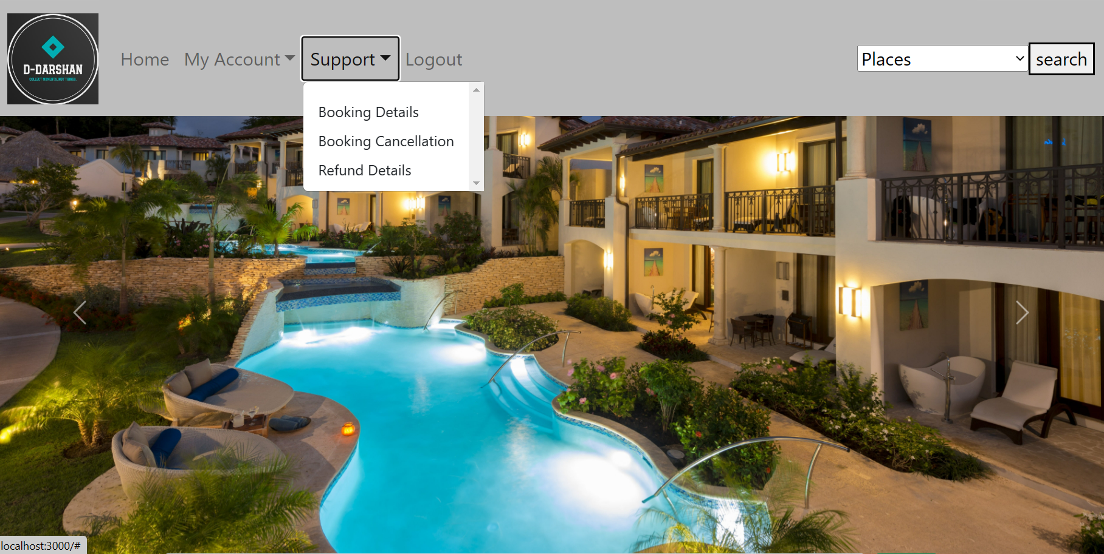

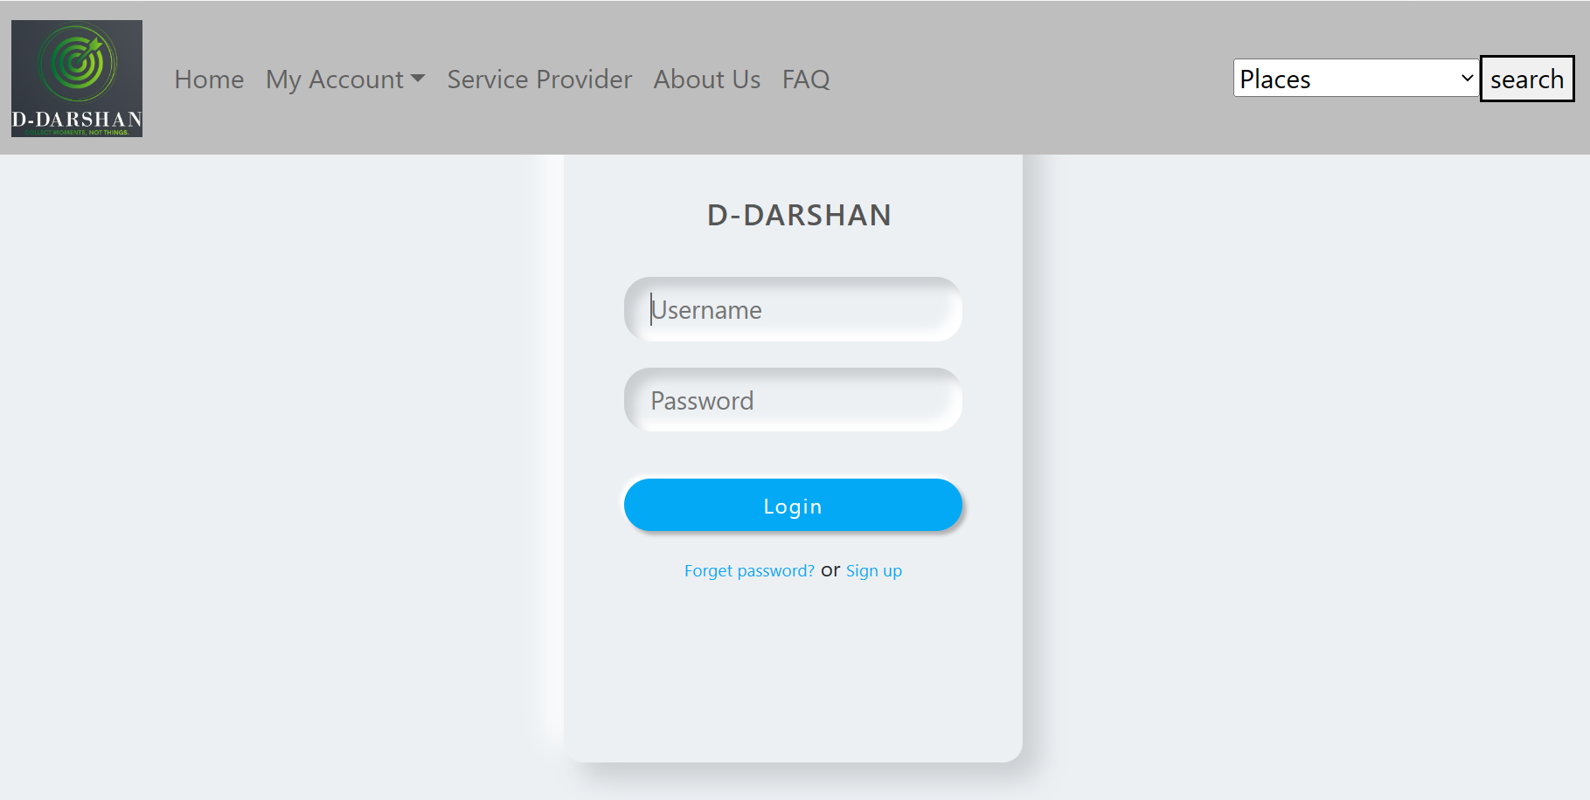

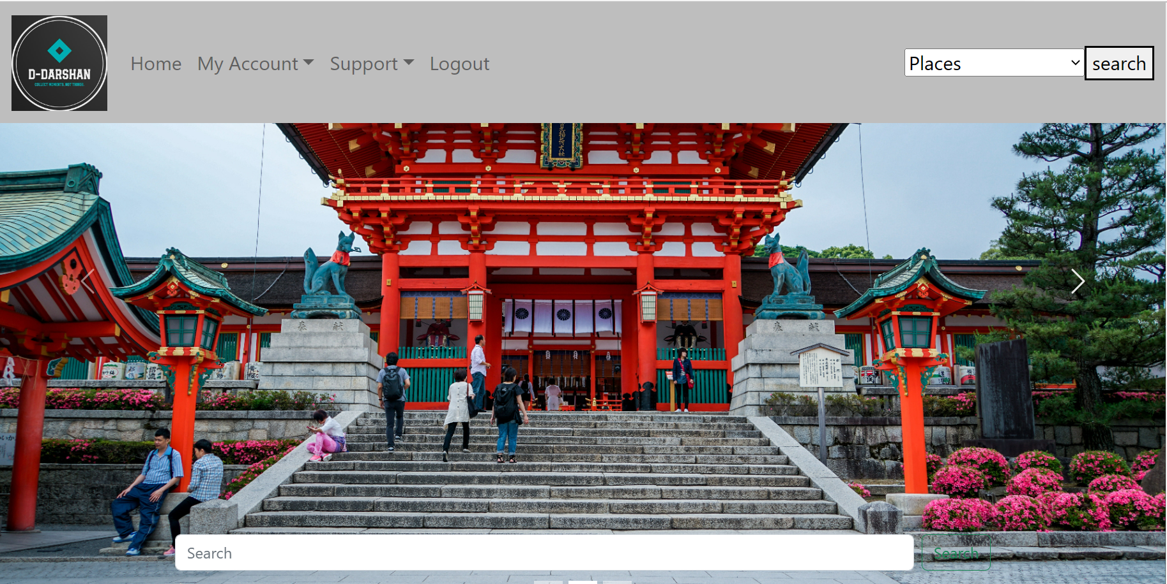

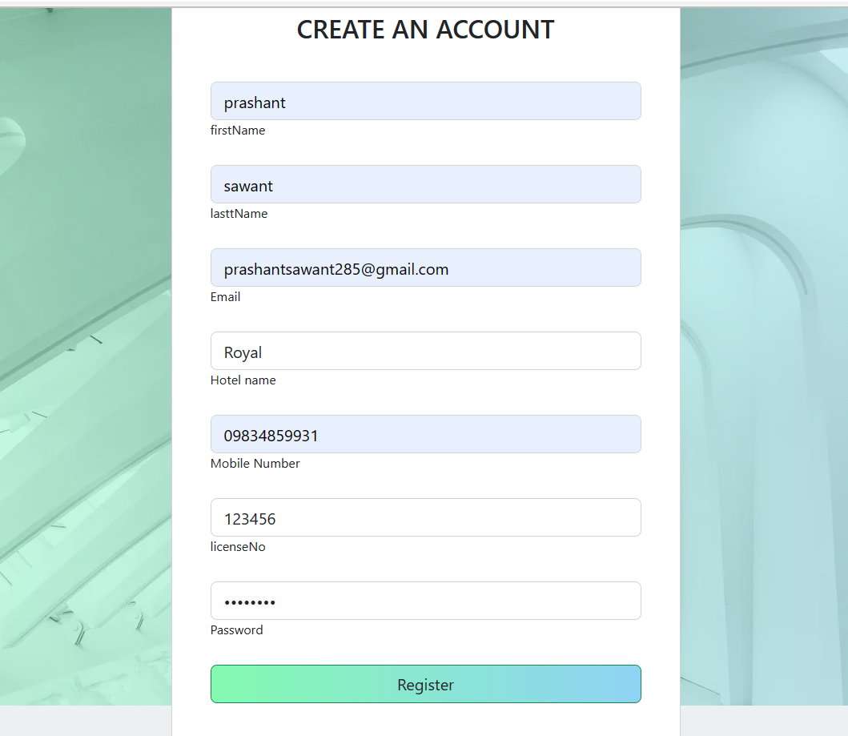

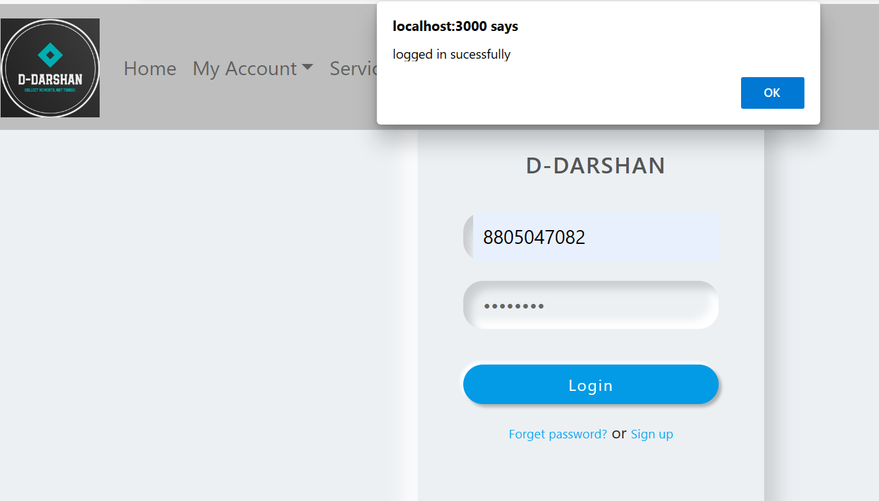

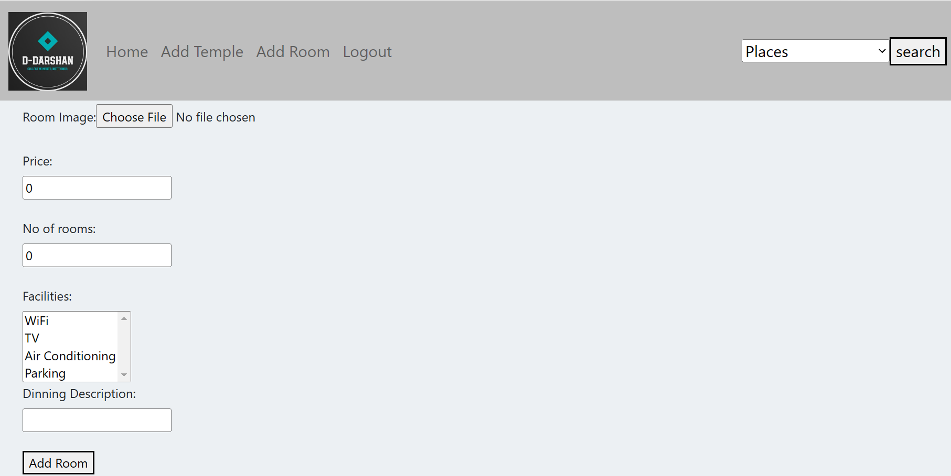

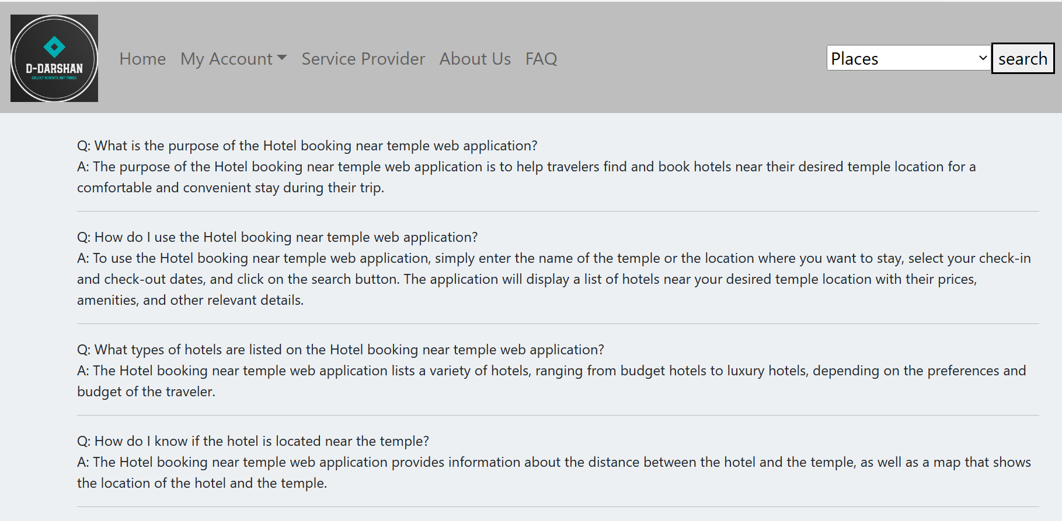

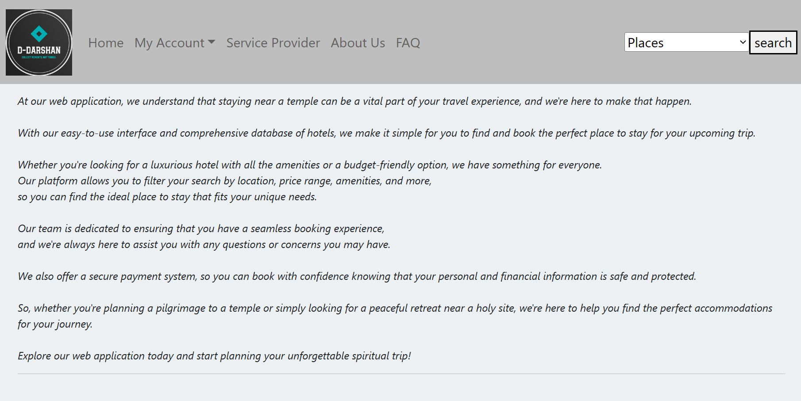

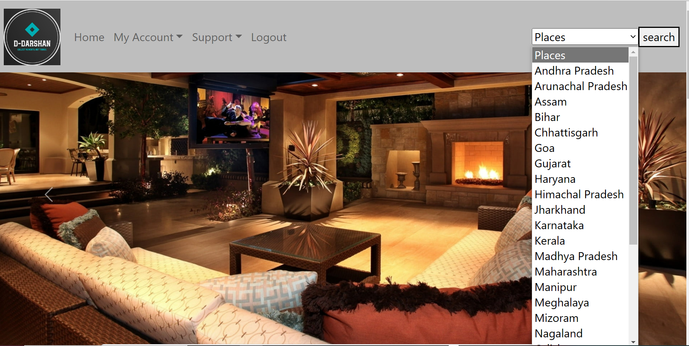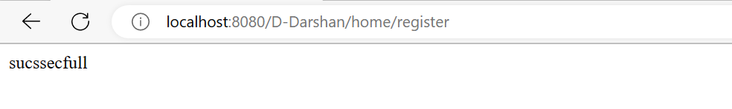

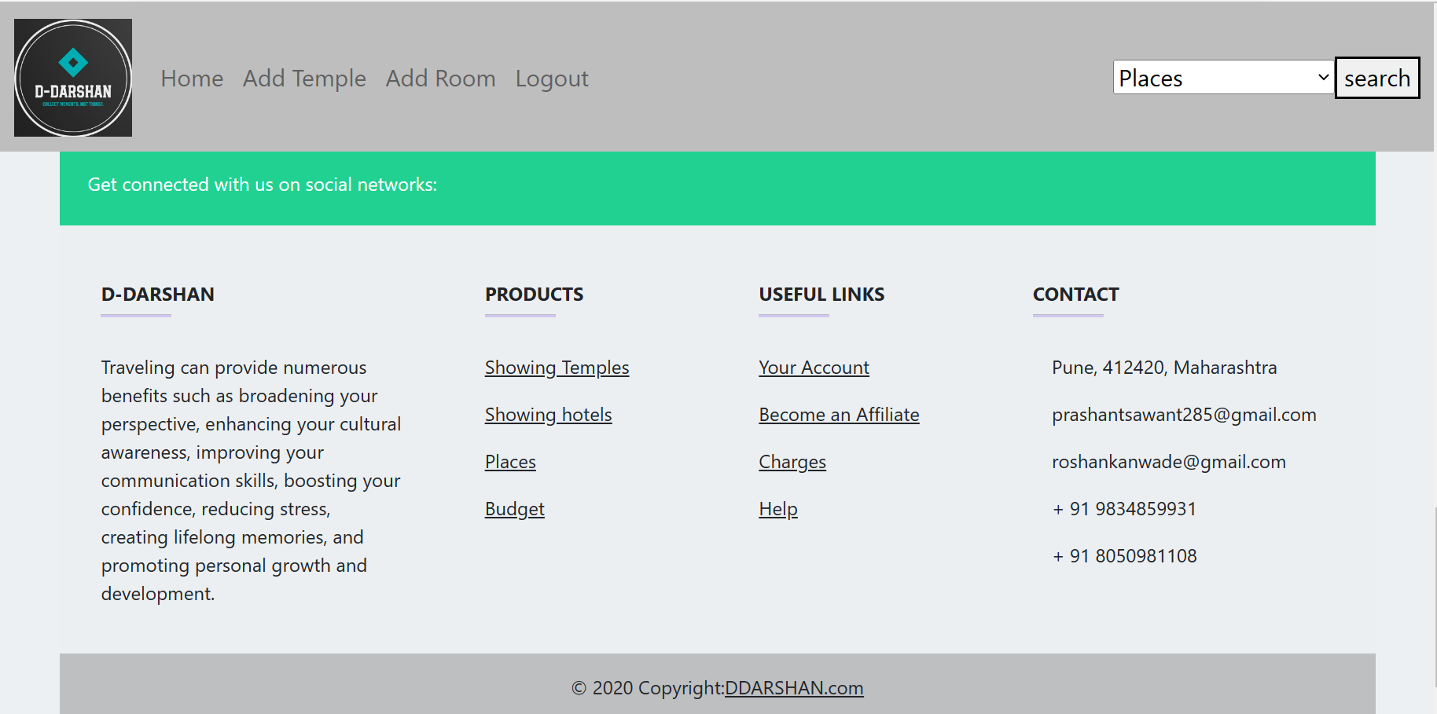

# CONCLUSION

The project entitled **D-DARSHAN** was completed successfully.

The system has been developed with much care and free of errors and at the same time it is efficient and less time consuming. The purpose of this project was to develop a web application for booking hotels near temples.

Booking a hotel near temples can be a convenient option for travelers looking to explore and experience the cultural and religious significance of these places. Staying near a temple allows for easy access to the site, which can save time and provide a unique opportunity to witness the rituals and customs of the local community.

This project helped us in gaining valuable information and practical knowledge on several topics like designing web pages using React.js, usage of responsive templates, designing of web application, and management of database using MySQL. The entire system is secured. Also, the project helped us understanding about the development phases of a project and software development life cycle. We learned how to test different features of a project.

There is a scope for further development in our project to a great extent. A number of features can be added to this system in future like providing moderator more control over activity so that each moderator can maintain their own work.

# REFERENCES

1. JavaScript Enlightenment, Cody Lindley-First Edition, based on JavaScript 1.5, ECMA-262, Edition
2. Mc Graw Hill’s, Java: The complete reference 7thEdition, Herbert Scheldt

1. Complete CSS Guide, Maxine Sherrin and John Allsopp-O'ReillyMedia; September 2012

**ONLINE REFERENCE**

* 1. [www.Google.com](http://www.google.com/)
  2. [www.w3school.com](http://www.w3school.com/)
  3. [www.javatpoint.com](http://www.javatpoint.com/)
  4. [www.gfg.com](http://www.gfg.com)